INTRODUCTION TO AEM

1.Open AEM in debug mode

To open AEM in debug mode we shall execute the following command:

java -jar cq5-author-4502.jar -fork -forkargs -- -Xdebug -Xrunjdwp:transport=dt_socket,address=59865,suspend=n,server=y -Xmx1520m -XX:MaxPermSize=512m -XX:-UseSplitVerifier

2.How to identify if AEM is Publish or Author?

We can check through the following link:

http://localhost:4502/system/console/status-slingsettings

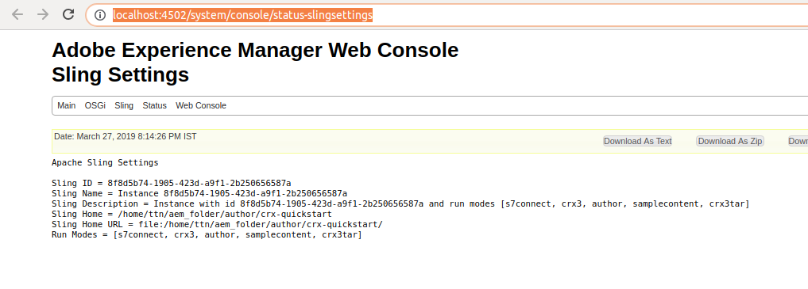
3.Where are all the bundles installed in AEM resides in system? Search for bundle “com.adobe.granite.ui.

AEM stores the bundle inside the folder-/home/ttn/aem_folder/crx-quickstart/launchpad/felix

Hence the above bundle can be found inside felix folder. To identify the bundle use the unique id given by osgi to every bundle:

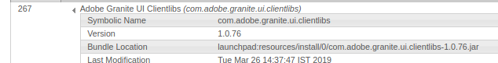

4.How can we specify in the command line the ‘port’ and ‘host’ while installing the project

We can specify by following command -

\mvn clean install -PautoInstallPackage -Daem.host=localhost -Daem.port=4502

5.Why do we specify SNAPSHot in the project version?

Snapshot is a special version which indicates the current development copy of the project which is being worked on. For each build, maven always checks out for a SNAPSHOT of the project.
Hence, whenever maven finds a newer SNAPSHOT of the project, it downloads and replaces the older .jar file of the project in the local repository.

